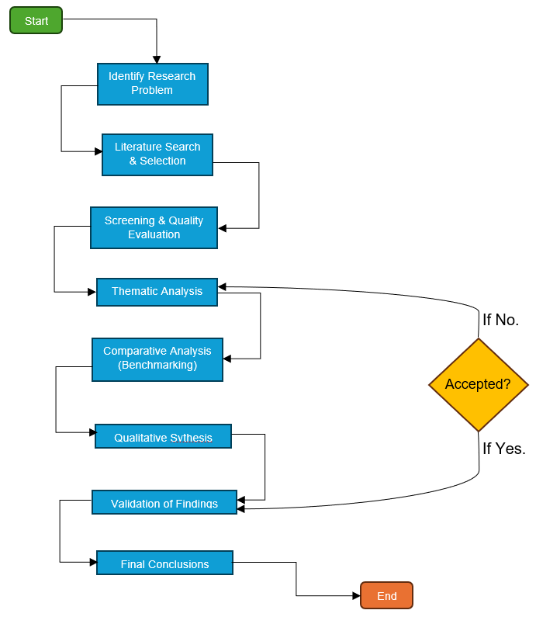


Deloitte UK also struggles to fully integrate ESG principles amid rising regulatory pressure, especially from frameworks such as the EU CSRD (Deloitte, 2025). Concerns about ESG-washing and delays in adopting mandatory UK sustainability standards weaken organisational transparency (Dasinapa, 2024). To meet client expectations and regulatory scrutiny, Deloitte UK must strengthen ESG implementation and improve accountability and reporting quality (Yusof and Azis, 2024).
Deloitte UK faces persistent talent retention challenges driven by burnout, long working hours, and inadequate employee development opportunities (Andalib, 2024). Consulting-sector burnout affects nearly half of employees and directly increases turnover (BCG, 2024). Recent layoffs linked to the global consulting slowdown have further reduced employee confidence (Yahoo Finance, 2025). To this end, competition for AI and tech skills intensifies retention difficulties, underscoring the need for stronger HRM practices and wellbeing support (Eaglehill Consulting, 2024).
References
Andalib, T.W. (2024). Effect of human resource management practices on employee retention of Deloitte Bangladesh Ltd. Bracu.ac.bd, [online] 14(23). doi:https://doi.org/ID%2021264001.
BCG (2024). Half of Workers Around the World Are Struggling with Burnout. [online] BCG Global. Available at: https://www.bcg.com/press/11june2024-half-of-workers-around-the-world-struggling-with-burnout [Accessed 22 Nov. 2025].
Dasinapa, M.B. (2024). The Integration of Sustainability and ESG Accounting into Corporate Reporting Practices. Advances In Applied Accounting Research, 2(1), pp.13–25. doi:https://doi.org/10.60079/aaar.v2i1.167.
Deloitte (2025). Environmental, Social & Governance. [online] Deloitte Insights. Available at: https://www.deloitte.com/us/en/insights/topics/environmental-social-governance.html [Accessed 22 Nov. 2025].
Deloitte UK (2025a). Deloitte UK Press Release: Sustainability Reporting Insights. [online] Available at: https://www.deloitte.com/uk/en/about/press-room/deloitte-uk-financial-results.html [Accessed 23 Nov. 2025].
Department for Education (2024). Skills shortages in the UK economy 2024 Evidence Summary. [online] Available at: https://www.edge.co.uk/documents/480/DD1279_-_Skills_shortages_bulletin_summary_2024_FINAL.pdf [Accessed 23 Nov. 2025].
Eaglehill Consulting (2024). The state of worker burnout: 2023. [online] Available at: https://www.eaglehillconsulting.com/insights/worker-burnout/ [Accessed 22 Nov. 2025].Edge Foundation (2023). The Open University Business Barometer 2023. [online] Available at: https://www.britishchambers.org.uk/wp-content/uploads/2024/06/The_Open_University_Business_Barometer_2024.pdf [Accessed 23 Nov. 2025].
Yahoo Finance (2025). Deloitte lays off employees in US consulting division. [online] Yahoo Finance. Available at: https://finance.yahoo.com/news/deloitte-lays-off-employees-us-103139738.html [Accessed 22 Nov. 2025].
Yusof, S. and Azis, S. (2024). Internal auditors’ role in addressing ESG reporting challenges at Deloitte India / Suraya Yusof and Saflina Azis - UiTM Institutional Repository. Uitm.edu.my, [online] 42(23). doi:https://ir.uitm.edu.my/id/eprint/105739/1/105739.pdf.
This research plan provides a structured, ethically grounded, and evidence-based framework for analysing Deloitte UK’s talent retention and ESG integration challenges, enabling the development of credible insights that support strategic organisational improvement.
Conclusion
Coming up with the synthesis of secondary data based on a variety of industry, regulatory, and academic sources was a challenge because of inconsistent reporting of ESG practices and different labour market measures. In order to solve this, cross-validation of information on various sources that were located in the UK was done to make it reliable and accurate.
Figure 4: FTSE 100 companies with ESG restatements in 2025 (46%) compared with companies without restatements (54%). Among restatements, 77% were due to greenhouse gas (GHG) emission metric adjustments.
Source: Deloitte UK (2025b).
- A qualitative secondary research design will be adopted which focuses on examining Deloitte UK’s talent retention and ESG integration challenges.
- An exploratory–descriptive approach is used to understand the organisational issues by analysing documented evidence from relevant sources
- Data is collected from peer-reviewed journals (2019–2025), Deloitte Insights UK publications, Big Four industry reviews, ESG regulatory updates, and reputable business sources such as BCG, McKinsey, CIPD, and government publications.
- A thematic analysis framework is applied to group findings into key themes (e.g., burnout, skills shortages, ESG compliance).
- Insights from UK-specific sources are cross-validated and synthesised to identify converging patterns, contradictions, and organisational implications, enabling evidence-based recommendations tailored specifically to Deloitte UK’s talent and ESG issues.
Reflection
Research Plan
Figures 3 and 4 indicate that while a majority of FTSE 100 firms have adopted net-zero commitments, widespread ESG restatements persist, emphasising the strategic importance of enhancing Deloitte UK’s ESG practices to meet rising accountability and reporting standards.
Figure 1: Proportion of UK consulting organisations experiencing skill shortages in 2023 (73%) versus those not experiencing shortages (27%).
Source: Edge Foundation (2023).
As illustrated in Figures 1 and 2, the high proportion of UK organisations experiencing skill shortages, together with the persistent level of skill-shortage vacancies over time, reveals a structural talent gap that directly heightens Deloitte UK’s challenges in securing and retaining specialised consulting professionals.
Figure 2: Percentage of UK vacancies attributed to skill shortages from 2021 to 2025, showing a decline from 38% to 25%.
Source: Department for Education (DfE) Sector Skills Report (2024).
Figure 3: Number of FTSE 100 companies that have adopted net-zero emissions targets in 2025 (79%) compared with those that have not (21%).
Source: Deloitte UK (2025a).
Data Presentation and Analysis
Research Aim & Objectives
Research Problem and Business Challenges
To investigate and propose strategies for improving talent retention and the integration of Environmental, Social, and Governance (ESG) principles within Deloitte, UK.
Objectives
- Evaluate current talent retention strategies at Deloitte, UK.
- Analyse the integration of ESG principles within Deloitte UK’s organizational culture and client operations.
- Identify key challenges and opportunities for improving talent retention and ESG integration at Deloitte, UK.

Challenge 1: Talent Retention
Challenge 2: ESG Integration
Improving Talent Retention and ESG Implementation Strategies at Deloitte, United Kingdom.
MSc Management, Consultancy Project Proposal
SRN: XXXXXXXXX

